


Regional
Overview
The information contained within this overview applies specifically to the stated ECA and provides additional detail for CFO stakeholders. This regional overview is a live document so will be regularly update. This document is not legally binding it is for reference and information purposes only.

Please note that the information provided is subject to change and should not be considered a complete picture of the delivery landscape, rather it should be used as a starting point when building proposals for submission.

Stakeholders
Contents
Stakeholders 1
Contacts 3
Programme Aim 3
The ESSP Model: 3
CFO Evolution programme – progression route 4
Target Cohort 5
Regional Map 6
Outliers and Feeders 6
Feeders 6
Outliers 7
CFO Evolution custodial delivery locations 7
CFO Evolution wing cohorts and wing locations 7
CFO Evolution community delivery locations 9
South West stakeholders & alignment with other services 9
Key stakeholders Seetec will engage with 9
Additional Considerations 10
Women 10
Veterans 10
HMPPS Commitment The following support will be provided through the Memorandum of Understanding: 11
Commissioned Rehabilitative Services 11
Implementation Plan and Key Deadlines 0
Community Location Updates 0
Referrals 0
Frequently Asked Questions 1
CFO Good News Story 1

The successful implementation and delivery of CFO Evolution will depend in large part on relationships. Effective engagement and managing relationships with stakeholders are both fundamental to the function of CFO, to ensure that duplication of both resource and effort is minimised.
There is an expectation that CFO providers will work closely with a range of identified stakeholders in custodial and community delivery sites (most notably Probation/CRS, Prison Education Service, Pre-release Teams, New Futures Network etc.), to ensure effective alignment of provision. Engagement also facilitates effective referral routes for participants who may benefit from CFO Evolution support.
This overview document provides a starting point for discussions and should be considered a live document, which will be expanded and updated throughout mobilisation and delivery.

Contacts

Provider for South West: Seetec
Contract Performance Manager: Tim Hicks
Email: CFO-Communications@justice.gov.uk
CFO-ContractManagement@justice.gov.uk

Programme Aim
The CFO Evolution programme has four aims:
- Aim 1: To provide a demonstrable sense of purpose for specific cohorts of offenders with complex needs by presenting them with clearly defined progression routes spanning both the custodial and community components of their total sentence,
- Aim 2: To provide safe spaces where offenders can, and importantly are, keen to engage in a range of positive activities designed to foster community buy-in, increase wellbeing and develop the skills required to navigate through the array of issues that present barriers to successful community reintegration,
- Aim 3: To increase effective engagement with mainstream or core services for those groups traditionally excluded,
- Aim 4: To encourage participation in activities to assist individuals to lead law abiding lives.

The ESSP Model:

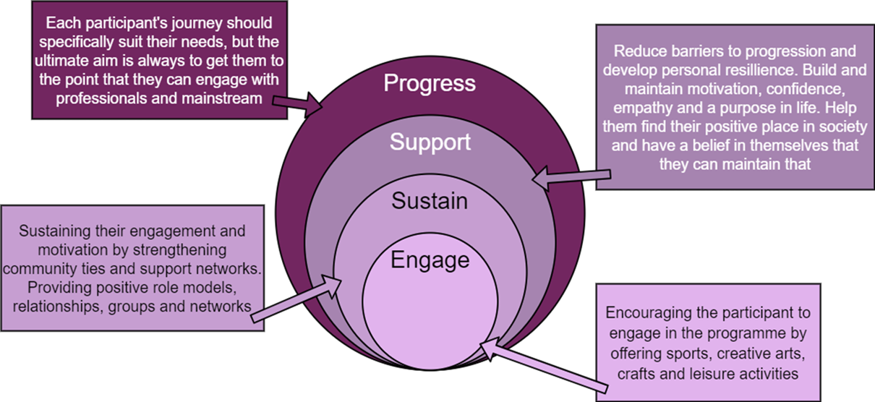

CFO Evolution programme – progression route
The CFO Evolution programme will consist of a clearly defined progression route, either:
- beginning in custody, moving through-the-gate, continuing into the community, and ultimately leading to successful community reintegration,
- for those sentenced to community orders, beginning in the community and leading to stabilisation within that community, or
- for prison leavers, not engaged during custody, beginning in the community and leading to successful community reintegration.

It will offer tailored support for offenders - particularly those who are considered disadvantaged, are ill-equipped to effectively engage with the mainstream, face barriers preventing them from successfully reintegrating into their local community, lack the hard and softer life/functional skills required by employers and are not fully supported by existing programmes. The provision is voluntary for participants.

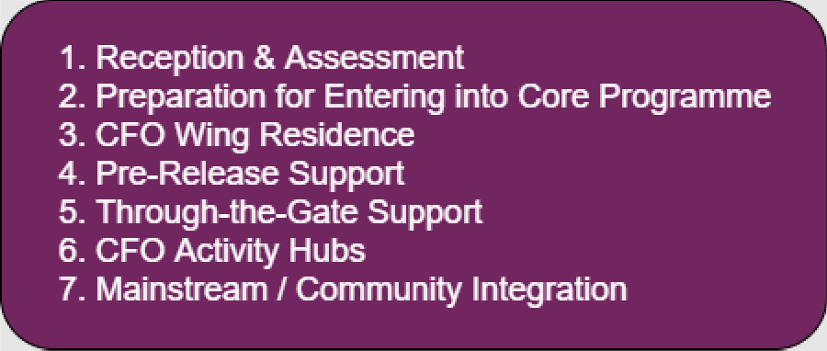

Target Cohort

The CFO Evolution programme will target those offenders least likely to meaningfully engage or fully co-operate with mandated / core provision. A high proportion of offenders in custody will be concerned about their ability to secure stable accommodation and employment on release. As they move closer to release, their anxiety will increase, particularly where they have not had sufficient opportunity to address the barriers preventing them from resolving these issues. Additionally, significant numbers will be at risk of drifting back into criminal and anti-social behaviour during the critical 3-month post-release period. For those already in the community, many will already be trying to navigate logistical challenges e.g. related to accommodation or finances. For some, the nature of their offending may present additional barriers to resettling into their local community or strengthening ties to family, friends and support networks generally. These individuals should form the majority of the throughput for the programme.
CFO provision should both complement and add value to core HMPPS delivery. It is expected that many Participants will also be receiving support from CRS suppliers parallel to accessing CFO services. There will be a specific requirement to work closely with Probation Practitioners and CRS suppliers, to ensure that duplicate services are not delivered as part of CFO support. CFO providers will be required to evidence consistent engagement with CRS particularly, to ensure that the services delivered do not duplicate any delivery by CRS suppliers.
Local protocols should be developed to enable close working relationships across each ECA and a clear understanding of what is being delivered. Participants are expected to receive CFO support alongside Probation/CRS services, as this is a key element of the CFO approach. This will only be effective if there is sufficient awareness of both statutory and peripheral support on offer. CFO provision should both complement and add value to core HMPPS delivery

Regional Map

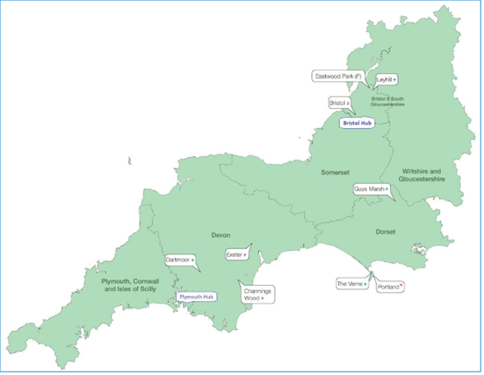
Blue bold text represents Main Hubs (Satellite Hubs are in blue text) Wing prisons are denoted by * Feeder prisons are denoted by # Outlying prisons are denoted by + Contract out prisons are in a grey bubble with a (C) Female prisons are denoted by (F) YOI–Young Offenders Institute High Security estate is in a red bubble
Each prison and Hub are designated with a specific purpose. The Wing Prisons having specific provision in a dedicated wing; the Feeder Prisons being generally large local prisons, where prisoners do not spend prolonged periods of time, and transfer prisoners to other prisons, specifically the Wing Prison. Additional provision is required in the Outlying Prisons as well as specialist, appropriate provision in the Female Prisons.

Outliers and Feeders
There will be provider staff based in Outlier and Feeder prisons, supporting the CFO Evolution programme.

Feeders
In the context of the CFO Evolution Programme, Feeders are those prisons which provide a high volume of transfers to prisons hosting a CFO Wing. They are typically large local prisons which receive high volumes of offenders direct from court. They are still likely to release significant numbers to some or all of the areas within an Evolution Contract Area serviced by a CFO Activity Hub, particularly where these are people serving short custodial sentences.

Outliers
In the context of the CFO Evolution Programme, Outliers are those prisons which provide a low to moderate volume of transfers to prisons hosting a CFO Wing. They are representative of a range of functions and categories. They may also release significant numbers to some or all of the areas within an Evolution Contract Area serviced by a CFO Activity Hub.

CFO Evolution custodial delivery locations

 | Wing Prisons | Feeder Prisons | Outlying Prisons | Female Prisons
South West | Portland | Exeter | Channings Wood | Eastwood Park
South West |  | Bristol | Dartmoor
South West |  |  | Leyhill
South West |  |  | Guys Marsh
South West |  |  | The Verne

CFO Evolution wing cohorts and wing locations
Please note information may be subject to change
Prison | Cohort and Sub-Groups | Stabilising Cohort | Wing Location
HMP Lancaster Farms | Lifers/Indeterminant Sentences  Young Adults- (21-35yrs)  Recall from parole | Indeterminant Sentences Prisoners | Buttermere 2
HMP Risley | Veterans  People convicted of sexual offences (PCOSO)  Neuro Diverse  Short Sentenced | Veterans | Discovery
HMP Holme House | Veterans  Young Adults | Veterans | Endurance
HMP Northumberland | Indeterminant Sentences  Young Adults  Neuro Diverse | Indeterminant Sentences | Houseblock 1
HMP Humber | Short Sentence  Travelling Community  Young Adults  Muslim Prisoners | Young adults with longer to serve | D wing
HMP Moorlands | Young Adults  Care Leavers | Indeterminant sentences with care experience | Houseblock 5
HMP Wealstun | Family Issues  Care leavers | Older offenders | D wing
HMP Drake Hall | Female non engagers | Lifers | Norwich/Margate
HMP Featherstone | Recall  Indeterminant sentences/ Lifers  Long sentences | Indeterminant Sentences | House Block 2
HMP Ranby | Short Sentences  Care experience  Veterans | Veterans | Houseblock 3
HMP The Mount | Care Leavers  No family ties  Short Sentence  Indeterminate sentences | Indeterminant Sentences/Lifers | Dixon
HMP High Down | Indeterminant Sentences, Lifers and Extended Determinant Sentences | Indeterminant Sentences/Lifers | Houseblock 5
HMP Portland | Young Adults  Neuro Diverse | Lifers | Collingwood
HMP Rochester | Neuro Diverse  No family ties  Care Leavers | Incentivised substance free living prisoners/Peer Mentors  Incentivised substance free living | Headcorn

CFO Evolution community delivery locations
please note additional community outreach locations will be added during mobilisation.
 | Main Hub | Satellite Hubs
South West | Bristol | Plymouth

There will be a number of specific priority groups for which targeted provision is required (predominantly across the custodial estate). These cohorts will form part of the CFO offer in each contract area. Providers will consider how each group will be supported through the progression route and tailor services/delivery approach accordingly. Consultation with stakeholders and CFO Evolution Providers will continue over the coming months and once delivery is embedded, priority groups will be selected and shared with regional stakeholders.

South West stakeholders & alignment with other services
Stakeholder engagement is critical for the success and sustainability of the CFO Evolution programme. Effective communication and engagement with stakeholders are key to driving referrals and enrolment onto the CFO Evolution programme, which will improve and sustain provider delivery performance.
CFO providers will be required to capture ongoing engagement with stakeholder throughout the CFO Evolution programme.
South West CFO Evolution provider, Seetec will link in with key stakeholder to support the delivery of the CFO Evolution programme

Key stakeholders Seetec will engage with

Community
- Probation (PDU, UPW, Health & Justice Lead, Women SPO Lead)
- Community Accommodation Service - Tier 1
- Community Accommodation Service - Tier 2
- Community Accommodation Service - Tier 3
- Commissioned Integrated Services (services for males and females)
- NHS (including Reconnect)
- Courts
- Department of Work and Pensions (DWP)
Custody
- Healthcare
- Neurodiversity support managers
- Prison Education
- Resettlement Passports
- Prison Employment Lead and banking and ID services (NFN)
- IAG Provider
- OMiC
- Pre-Release Team
- Short sentence function
- Head of Reducing Reoffending
- Strategic Housing Specialist
- Family Services

Additional Considerations

Women

The Female Offender Strategy (FOS) and newly published FOS delivery plan set out the Government’s commitment to better outcomes for women in custody and on release and the requirement to adopt a gender specific and trauma informed approach. An approach that takes account of the unique needs and backgrounds of women is most effective in addressing their offending behavior.
- Specific consideration will be given to; older female offenders, those serving short sentences, women aged 18-24.
- Within the CFO wings, there will be an awareness and consideration of mental health; self-harm; neurodiversity and trauma informed delivery.
- Within the CFO Activity Hubs, there will be consideration of women only days/space and the potential to have female staff available.
- CFO Evolution delivery Providers will be required to build strong relationships with regional women’s services and offer additional gender specific support services to women in custody and on release.

Veterans
HMPPS recognises the need to offer tailored support for ex-Armed Service Personnel being managed within the criminal justice system as virtue of being convicted of a criminal offence. CFO collaborate closely with specialist organisations to ensure that support for veterans is consistent and accessible across each region.
During onboarding a new participant, Providers will ask if an individual has previously served in the UK Armed Forces and will be linked in via the HMPPS Veterans Lead with veterans’ services and charities.

HMPPS Commitment
The following support will be provided through the Memorandum of Understanding:
- Access to HMP information regarding contact points for prisons (ViCSOs) where relevant and previously agreed with HMP staff/volunteers
- Advice on veteran population across the custodial estate
- Facilitate meetings with relevant regional veteran reps/prisons/Governors (where necessary)
- Feedback on services received and help to support and implement any changes
- Promote the support provided by veteran charities at a policy level which will include responses to Ministers when requested
- Ad-hoc support and advice regarding individual veterans or services generally in the custodial estate
- Access to ‘Military Human’ training which is being rolled out as part of HMPPS support to raise awareness of needs of group
- Staff/volunteers will be made aware of risk related information where this is relevant to their own safety or that of any other party
- Promote support available from the charities via HMPPS CFO Veteran Support Map
- Relevant and/or mandatory training from prisons i.e. equalities and offender interaction awareness
- Any other training where appropriate and must link with Offender Management Units
- Contact point for any veteran related query (cfo-mod@justice.gov.uk) which can’t be met/answered at establishment level
- Support with the vetting process prior to any access to prisoners will be provided at an establishment level
- Should an organisation or prison raise concerns/ compliant then a standard process will be followed

Commissioned Rehabilitative Services
CFO Evolution provision will not replace or replicate existing mainstream/core activity but will support and complement services delivered by core partners including, Commissioned Rehabilitative Services (CRS). Engagement with CRS partners will occur at both a national and regional level, thus ensuring complementary working and a cohesive approach to reducing reoffending.

Implementation Plan and Key Deadlines
Throughout June and July, following contract award, CFO Contract Performance Managers (CPM) will chair regular mobilisation meetings with Providers and Prison Stakeholders. During these meetings the CPM will work with the Provider in relation to their implementation plan and key timelines as submitted in their tender response. Agenda items can cover the following topics:
- Review of Mobilisation Plan
- Estates
- Staffing
- Wing Mobilisation
- Stakeholder Engagement
- IT
- Risks
- AOB
Community calls with regional Heads of Community Integration will begin from mid-July with the CFO Stakeholder Lead and will cover the following topics:
- Current delivery position to date
- Mobilisation update for their region
- Overview of locations
- Referral process
- AOB
- Legislation / policy changes (where applicable)

Community Location Updates
Please note that this is a live document, and this may be updated throughout the mobilisation period.
Your Provider, Seetec will be opening a new Hub in Plymouth, the Bristol site will remain at its current location. As soon as we have further information this section will be updated.

Referrals
CFO have created a new referral form to capture all referrals centrally and disseminate these to the CFO Evolution Providers. Referrers will be asked to complete the form and choose which region this is sent to. This will then be sent to CFO Providers through secure email. This is an automated process which allows CFO to collect referral data to inform engagement and communications in each region.
CFO Evolution Referrals – HMPPS Creating Future Opportunities

Frequently Asked Questions
Please note that this is a live document, and responses may be updated throughout the mobilisation period.
- Can offenders in work or education access CFO support?
  - Yes
- Can you work with participants in this mobilisation period?
  - Yes, we are still working with existing caseloads, any referrals made to the new programmeine will be shared with the incoming provider from 1st August 2024
- Can participants be worked with during the last third of their sentence if unsupervised and how will the risks be reviewed?
  - CFO have refined how we will review risk. It will be reviewed every 10 weeks in both custody and community. Providers can continue to work with participants if risk has not been updated but this will be monitored. If no risk has been provided, risk will be assumed as high.
- Do participants have to exit the programme upon gaining employment, education or training?
  - Participants do not need to be finished on the programme once they have achieved an ETE outcome.

CFO Good News Story
Having moved from London to Bristol, Wendy* was transferred from The CFO Activity Hub in Croydon, to the Hub in Bristol. Moving into a new area is a major challenge for participants, not least for Wendy*. The Hub devised a fully inclusive plan which would help address all of Wendy*'s issues.

Arts and crafts would raise her confidence and positivity, sports helped her to get active and healthy, she enrolled on a CSCS course to improve her employability and attended Job Centre appointments, all with the guidance of her Support Worker.

Being frustrated with her new accommodation, the team took Wendy* on a tour of Bristol to give her local spaces to explore and time away from her Approved Premises. Wendy* would express her desire to improve the garden at her Approved Premises too. She knew that if the environment improved the women would spend more time utilising it.

To help, a Support Worker from the CFO Activity Hub would deliver gardening sessions there. Wendy* identified the work needed and the items that needed to be purchased; then led in clearing up the garden, picking up litter, weeding, making bird feeders, painting benches and fences - all making the space much more welcoming and helping Wendy* feel more at home. Since this the Bristol CFO Activity Hub have regularly worked with their local Approved Premises, helping the community of women to feel more comfortable in the local area.

